`DIS-MEX-Colima-Mortuary Urn

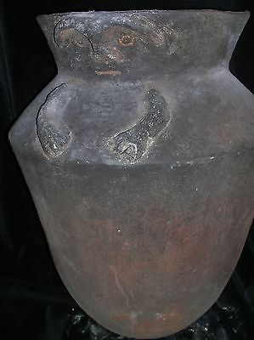

#### [orig $499 PRE COLUMBIAN COLOMBIA COLIMA CAVE/CRYPT URN FIGURE 23"](http://www.ebay.com/itm/321973258469)

|  |  |
| --- | --- |
| Item price | $249.99 |
| Quantity | 1 |
| Item number | 321973258469 |
| Shipping service | USPS Priority Mail |